Resolução ficha 2 CS (Matlab Corrigido)-

Pedro Perdigão A47701, Afonso Correia A47521, Ahmet Duran A48095, Diogo Justino A47694

Parte 1

1.2

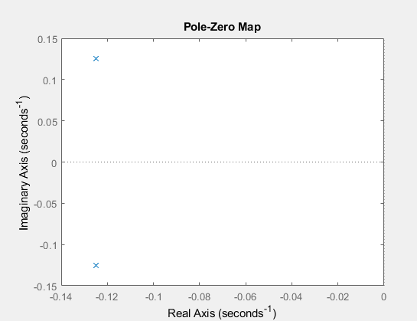

Parte 2

2.2

2.3

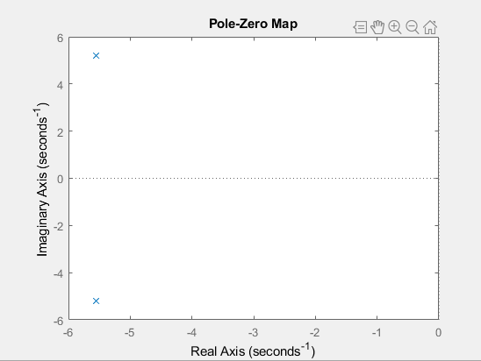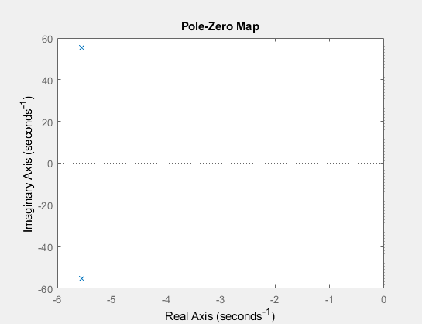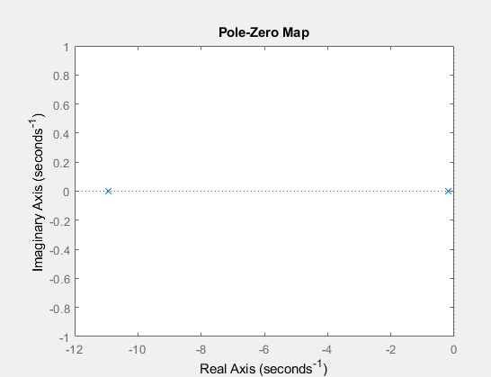

2.4

